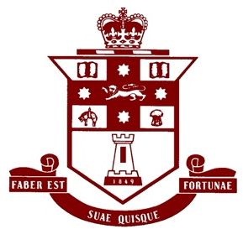 | The Fortians Union  Membership Form
Name
Surname at school
(if different)
Years at school | to
Email
Phone
Postal Address

Membership fees:
- Free for the first year after leaving school.
- $50 for Life Membership!
- Payment can be made online.
  - Pay it to: Fortians Union Ordinary a/c, BSB 112-879, Account Number: 015805952
  - Don’t forget to email payment details to don.newby@bigpond.com
- Or mail a completed form and post it with a cheque payment to:
  - The Fortians Union, 63 Acton Street, Croydon 2132

I agree to my personal information being given to other members of the Fortian Street community, including the P&C and Foundation.
Yes ___ No ___

Signed:
Date:

